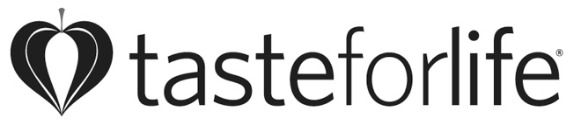

FOR IMMEDIATE RELEASE

Contact: *2017 Immunity Essentials Award
Lynn Tryba logo available upon request
Chief Content Officer
603-283-0034, ext. 188
lynn.tryba@tasteforlife.com

Keene, NH—Taste for Life Announces its 2017 Immunity Essentials Award Winners!
Make this year’s cold and flu season healthier by fighting back with nature’s weaponry. We’ve got effective immune-boosting herbs, vitamins, probiotics, and more gathered here for your consideration. If you don’t already have a trusted go-to (for many people, it’s echinacea or elderberry), we hope you find exactly what you need in our list.

Bee Prepared
Terry Naturally Propolis Extract

Cough Calmer
Quantum Health Cough Relief TheraZinc Lozenges

Enzymes
Enzymedica Enzyme Defense

Healing Teas
Numi Organic Turmeric Teas
Traditional Medicinals Organic Throat Coat

Homeopathy
Dr. King’s Natural Medicine Lungs & Bronchial Relief

Breathe Easy
Michael’s Naturopathic Programs Quick Immune Response
NOW Solutions Seasonal Changes Essential Oils Kit
Olbas Inhaler
Ridgecrest Herbals ClearLungs Immune
Xlear Xylitol All Natural Saline Nasal Spray

Kids’ Immunity
Garden of Life Dr. Formulated Probiotics Organic Kids +

Probiotics
Supplementing with probiotics reduces the number of colds people get—and shortens their duration.
Bio-Kult Advanced Multi-Strain Formula
Essential Formulas Reg’Activ Immune & Vitality
LoveBug Probiotics Colds Suck

Herbal Remedies
A. Vogel Echinaforce Forte
Nature’s Answer Sambucus Immune
Vibrant Health BullsEye

Daily Defense
Kyo-Green Powdered Drink Mix Harvest Blend Immune Defense
Irwin Naturals Immuno-Shield All Season Wellness
The Grandpa Soap Co. Epsom Salt Bar

Medicinal Mushrooms
Mushroom Wisdom Maitake D Fraction EZ Spray
Whole Earth & Sea Pure Food Super Mushroom

Whole Food Based
Bluebonnet Nutrition Targeted Choice Wellness Support

Vital Vitamins
American Health Ester-C
Country Life Vitamin D3 Spray

Magnesium & More
Natural Vitality’s Calmful Gut

Learn more at http://www.TasteforLife.com/immunity-essentials and look for the Taste for Life Essential Supplements Awards in February!

